**ADVANCED PROGRAMMING REPORT**

**PROJECT – CREATING A CLEANING CHECKLIST**

In this report I am going to elaborate my project which is a Cleaning Checklist Application with the help of Java language. I am going to showcases all the workings and programming principles required to make this project.

1. **PROJECT CHOICE EXPLANATION**

As I was searching for a student part time job and I got an opportunity to go for a trial day in a hotel. And as it was my first day in the hotel, I was observing all the workings done in a hotel and one thing which I noticed was that, the housekeeping team used to make the cleaning checklist with the help of pen and paper. So, then I thought what if the hotel can have a cleaning checklist application which can be more beneficial for them.

The main reason for making a Cleaning Checklist Application project is to help the hotel managers to solve all the operational challenges and can ensure rooms cleanliness consistently. This application is very easy to use in which it provides a checklist of all the cleaning tasks and record all the tasks done by an employee. The main idea is to make housekeeping easier and reduce the amount of time manager and staff spend checking everything manually.

1. **COMPETITOR ANALYSIS**

As the Marriot Hotels comes in one of the world best hotels. The Marriot hotels use Micros Opera software for their Hotel Management System in most of their properties. This software handles all the housekeeping tasks like tracking an employee performance.

If we look at small or medium sized hotels, they still follow traditional way of using paper-based checklist as they cannot invest in such type of expensive housekeeping management software.

So, this Cleaning Checklist project is designed to be simple and affordable specifically for all the small and medium scale hotels. By using this application, the hotel can customize and make their own checklist based on room size and different type of tasks need to be done with the staff. This all management can be done more easily and without investing that much money in it. In future this project can improve by integrating features like mobile app.

1. **OOP SKILLS**

This project showcases several Object-Oriented Programming (OOP) concepts and below I will highlight some codes from my project which highlights OOP principles.

* **ENCAPSULATION**
* This principle means putting all the related data (person age or name) and the actions that work on that data (like changing name) into a single class.

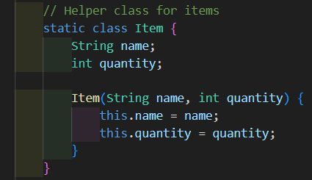

For example, this code is from the project, from line 160 to 169 the ITEM class encapsulates the data **name and quantity** and gives a structure to **store room- specific items.**

* **ABSTRACTION**
* 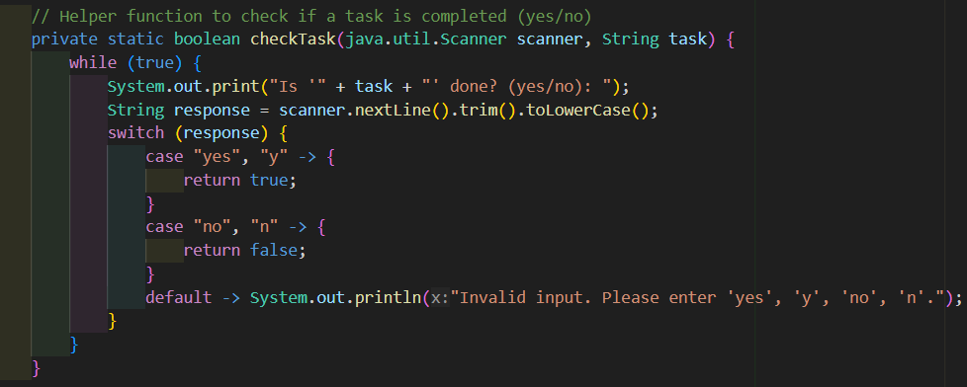These principle hides all the complex logic from the main method and makes the code easier to maintain and understand.
* From line 195 to 210, the **checkTask** method is used for checking if the cleaning task is done or not. The abstraction principle handles the user input (yes, y, no, n) and if the user enters something invalid then the method will keep asking again.
* Instead of putting all the details to get valid input directly in the main program, the abstraction method handles it separately and this make the main program focused on its overall task.

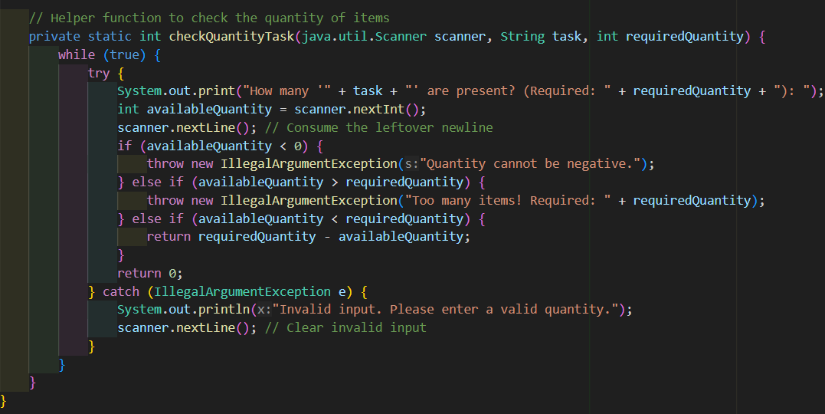

* From line 212 to 234, the **checkquantityTask** method is used, which abstracts the process of verifying the right number of items available in a room.
* It makes sure that if the user is entering a valid number and not entering any integer or any unrealistic values.
* In the above code, encapsulating rules is also implemented which includes rules about what counts as too many items. So, by implementing this method I don’t have to write those rules again.
* It will show clear output as if any items are missing it will tell you how many are missing and if everything is fine the output will come 0 which indicates that no items are missing.
* **POLYMORPHISM**
* 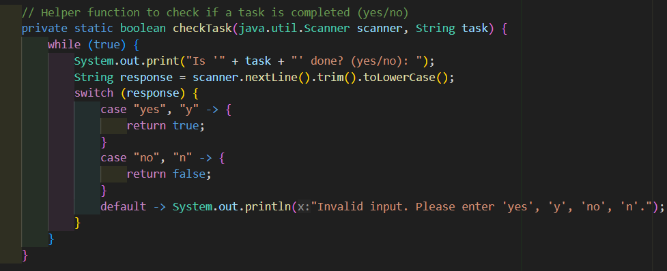This principle can be used on methods or functions to handle different situations in a flexible way.
* From line 195 to 210, the checkTask method can also handle different ways of saying yes or no (yes, y, no, n) and the method will understand each of these responses correctly as the method can handle different forms of input.
* After yes and no the result will show true or false based on whether the task is completed.

1. **TECHNOLOGY STACK**

* For this project I have used Java Programming Language and Java frameworks.
* The main reason for choosing Java for this topic is that the language is versatile and object-oriented programming language which provide robust tools which handle error checking, complex logic and user interaction.
* The Java language fits in this project as the program is based on a console application which handle user inputs, perform validation and generates report according to that.
* **JAVA FRAMEWORKS USED**
* **Libraries used in the program are –**
* **Java.util.List** is used for maintaining an ordered collection of room numbers and checklist.
* **Java.util.ArrayList** and **Java.util.Hashmap** are used for making dynamic list and fast lookups.
* The reason of using these libraries is that it simplifies the management of such dynamic data and also make efficient storage of information.
* These above libraries fit in this project as the collection manage rooms, tasks and room related data.
* **LOOPS AND CONDITIONAL**
* In this project I have used Java looping constructs like **for,while** and conditional like **if,else and switch-case.**
* I used this Java constructs as it provides a flexible way to handle all the repetitive tasks and decision dynamically like it is used to iterate through rooms, tasks and checking each input is validated and processed correctly.
* **SCANNER CLASS**
* I used **Java.util.scanner** for scanner as it gives a simple way to read user inputs from the console which includes both strings and numbers.
* It is used throughout the program such as gathering cleaner details, room information and task status.
* **JAVA STRING MANIPULATION**
* I have used **trim, tolowercase and matches** which is a good method for comparing and validating strings.
* I used for input validation and ensuring consistent user interactions like **checking if the name contains only letters.**
* I used such tools for this project as it makes a balance between simplicity and functionality for a beginner level console-based application. As with the help of Java standard libraries and features like exceptional handling makes it easy to create a robust program.

1. **INDUSTRY RELEVANCE**

This application is designed specially for the hospitality industry such as hotels and guest houses, where cleanliness and smooth operation are necessary.

By using this interactive and easy checklist application, the hotel staff can follow a clear and organized process to make sure that all tasks are completed and the program helps in reducing mistakes that can happen when people use paper-based checklist. By using this application, I strongly believe that a hotel can maintain its reputation and can run its operation more smoothly.

1. **PROJECT REFLECTION & CONCLUSION**

* While creating this application in Java it shows that how important is to focus on user interaction and error handling as there some people who are not familiar with the technology.

**SOME OF THE CHALLNGES THAT I FACED IN THE PROJECT**

* Creating a workflow which can handle different rooms sizes and their requirements without making the application to complicated.
* To ensure that the data entered by the users is correct and prevents error during the execution of the program.

**SOME OF THE POTENTIAL IMPROVEMENTS**

* Integrating the program to run on smartphones or tablets so that the hotel staff can update tasks in real time.
* Integrating some multiple languages so that hotel staff from different countries can also use this application comfortably.

**CONCLUSION**

This project showcases how Object-Oriented Programing can solve practical real-world problems. It provides useful application to the hotels which will ensure if the rooms are clean, well organized and whether all the tasks are completed by the employee or not. This program sets a really good base and with integrating more data in it can make this application a more complex operation.